5th June 2019
4-6 Dance Group
INTO THE SPOTLIGHT DANCE FESTIVAL
HAIR, MAKEUP & ACCESSORIES
Your child should arrive at the Seymour Centre at 7pm with their hair and make-up done.
Hair – slick, messy bun on the right side of their head with a side part. Hair band should match hair colour.
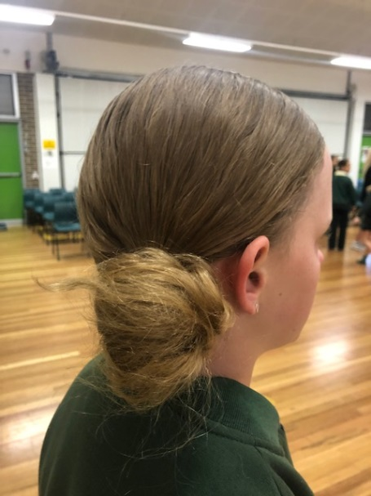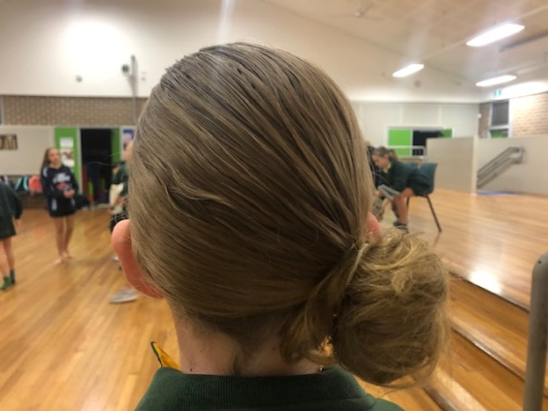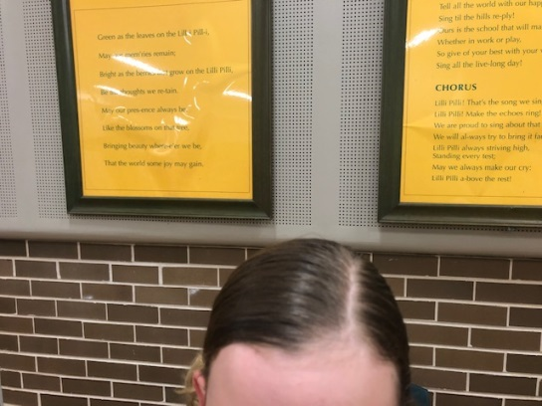
Earrings – small diamante type earrings to add a bit a sparkle. Lovisa at Miranda Westfield stock them
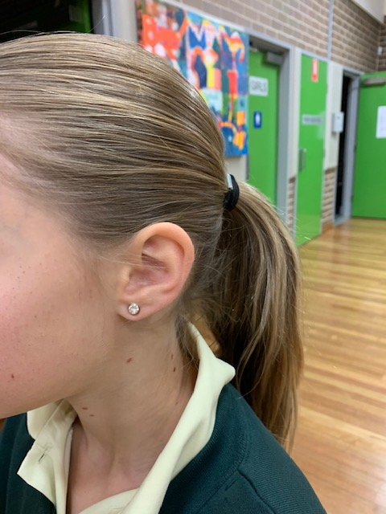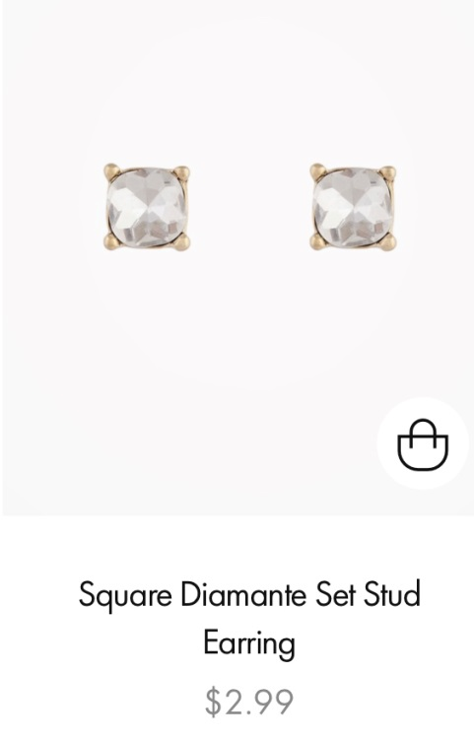

Make-up – brown, earthy shades for eyeshadow, black eyeliner, mascara and red lipstick.

