EN00968_1 May 2019

Dear Parents

This year’s band camp will be held on Monday 27 and Tuesday 28 May (Term 2 Week 5) at The Tops Conference Centre, Stanwell Tops. We will be staying in the Banksia and Acacia Sites.

Lilli Pilli band members will be combining with band members from the following public schools: Caringbah North, Bangor, Woolooware and Kareela. The camp is a wonderful opportunity for our students to experience how a full concert band works as well as get to know other children with similar musical interests. The camp will include intensive workshops for individual instruments and combined bands as well as lots of other exciting activities.

Transportation to the camp will be provided by parents and we will meet in the auditorium between 9:00 -9:15.

A finale concert (about 30 minutes) is planned for family members on the Tuesday evening at 7.00p.m in the Conference Centre’s Auditorium. Children will depart with their parents at the conclusion of the concert.

The cost of this camp will be $200.00 inclusive of accommodation, all meals, musical tuition and activities.

On Monday afternoon we will be taking advantage of some of the centre’s adventure activities which are run by the Centre’s trained staff. This has been a highlight of camp for many years. The activities being offered this year include Abseil Tower, Cart Racing, Survivor, and Giant Swing.

Please complete and return the accompanying ‘Acknowledgement of Risk’ and Activities Permission Form to allow your child to participate.

Mrs Michele Smith, Mr Adam Robinson and teachers from other participating schools will be accompanying the children.

Please return the following consent forms to Office by Friday 10 May (Term 2 Week 2)

* Camp Consent and Medical Form
* The Acknowledgement of Risk
* The Dietary Requirements Form

Payments should be made by Friday 17 May (Term 2 Wk 3)

Mrs Michele Smith Mrs Jane Shepherd

Band Coordinator Principal

What To Bring:

Children will need to bring the following items labelled:

1. Instrument and pencil
2. Music Folder
3. Music stand – with your name on it
4. Valve oil / reeds / cork grease

* Wet weather gear / rain coat
* Personal Medication (to be handed to Mrs Smith)
* Hat
* Jumper and / or Jacket
* Covered shoes (thongs & sandals are not recommended for outdoor use on site)
* Linen: 1 base sheet + top sheet or sleeping bag & pillow case. The conference centre supplies doona and pillows
* Toiletries
* Bath Towel
* Sleep Wear
* Underwear
* Change of clothes for each day
* Socks

Additional needs for those participating in Activities

* Extra pair of covered shoes
* Water bottle.
* Full length tops / shirts. Short tops are not suitable for activities, especially those involving harnesses.
* Long shorts for harnessed activities.

Note: Outdoor activities may result in damage / soiling of clothing. Please ensure clothing is suitable for outdoor recreational use.

Children should not bring any money, mobile phones, aerosol sprays or any valuable items to the camp.

\*\*\* If can get quite cold at The Tops, especially in the auditorium at night. Please make sure you have packed warm clothes.

BAND CAMP CONSENT AND MEDICAL FORM

* I hereby give consent for my child \_\_\_\_\_\_\_\_\_\_\_\_\_\_\_\_\_\_\_\_\_\_\_\_\_\_\_\_\_\_ of class \_\_\_\_\_\_\_\_ to attend the 2 day overnight camp at The Tops Conference Centre at Stanwell Tops on Monday 27 and Tuesday 28 May 2019.
* I understand that travel to Stanwell Tops is the responsibility of parents
* I understand that the group will be supervised by Mrs Michele Smith
* I understand that I must collect my child from the venue on Tuesday evening after the 7pm concert.
* I do / I do not give consent for my child’s photograph to be used in a slideshow that will be shown at the parent concert on Tuesday 28 May 2019.
* I **give / do not give** permission for my child to participate in the adventure activities while at band camp at The Tops Conference Centre.

Special needs of my child which you should be aware (e.g. allergies, medication, dietary requirements)

\_\_\_\_\_\_\_\_\_\_\_\_\_\_\_\_\_\_\_\_\_\_\_\_\_\_\_\_\_\_\_\_\_\_\_\_\_\_\_\_\_\_\_\_\_\_\_\_\_\_\_\_\_\_\_\_\_\_\_\_\_\_\_\_\_\_\_\_\_\_\_\_\_\_\_

\_\_\_\_\_\_\_\_\_\_\_\_\_\_\_\_\_\_\_\_\_\_\_\_\_\_\_\_\_\_\_\_\_\_\_\_\_\_\_\_\_\_\_\_\_\_\_\_\_\_\_\_\_\_\_\_\_\_\_\_\_\_\_\_\_\_\_\_\_\_\_\_\_\_\_

\_\_\_\_\_\_\_\_\_\_\_\_\_\_\_\_\_\_\_\_\_\_\_\_\_\_\_\_\_\_\_\_\_\_\_\_\_\_\_\_\_\_\_\_\_\_\_\_\_\_\_\_\_\_\_\_\_\_\_\_\_\_\_\_\_\_\_\_\_\_\_\_\_\_\_

In the event of illness or injury, I authorise the seeking of any medical assistance, on my behalf, that my child may require.

Medicare Number \_\_\_\_\_\_\_\_\_\_\_\_\_\_\_\_\_\_\_\_\_\_\_\_\_\_\_ (for use at medical centres, surgeries)

Contact Number Home \_\_\_\_\_\_\_\_\_\_\_\_\_\_\_\_\_\_\_\_\_\_\_\_\_\_\_\_\_\_ Work \_\_\_\_\_\_\_\_\_\_\_\_\_\_\_\_\_\_\_\_\_\_\_

Other Contact \_\_\_\_\_\_\_\_\_\_\_\_\_\_\_\_\_\_\_\_\_\_\_\_\_\_\_\_\_\_\_\_\_\_\_\_\_\_ (mobile or other person)

Contact person’s name (if applicable) \_\_\_\_\_\_\_\_\_\_\_\_\_\_\_\_\_\_\_\_\_\_\_\_\_\_\_\_\_\_\_\_\_\_\_\_\_

Signature \_\_\_\_\_\_\_\_\_\_\_\_\_\_\_\_\_\_\_\_\_\_\_\_\_\_\_\_\_\_\_\_\_\_\_\_\_\_\_ Date \_\_\_\_\_\_\_\_\_\_\_\_\_\_\_\_\_\_

Parent/Guardian

**Payment - Band Camp**

Student’s Name: \_\_\_\_\_\_\_\_\_\_\_\_\_\_\_\_\_\_\_\_\_\_\_\_\_\_\_\_\_\_ class \_\_\_\_\_\_\_\_

**The cost for camp is $200.**

Payments should be made by Friday 17 May (Term 2 Wk 3)

* I enclose $200 as payment for Band Camp
* I have paid $200 online and my receipt number is:

­­

Signed \_\_\_\_\_\_\_\_\_\_\_\_\_\_\_\_\_\_\_\_\_\_\_\_\_\_\_\_\_\_\_\_\_ Parent/Guardian Date \_\_\_\_\_\_\_\_\_\_\_

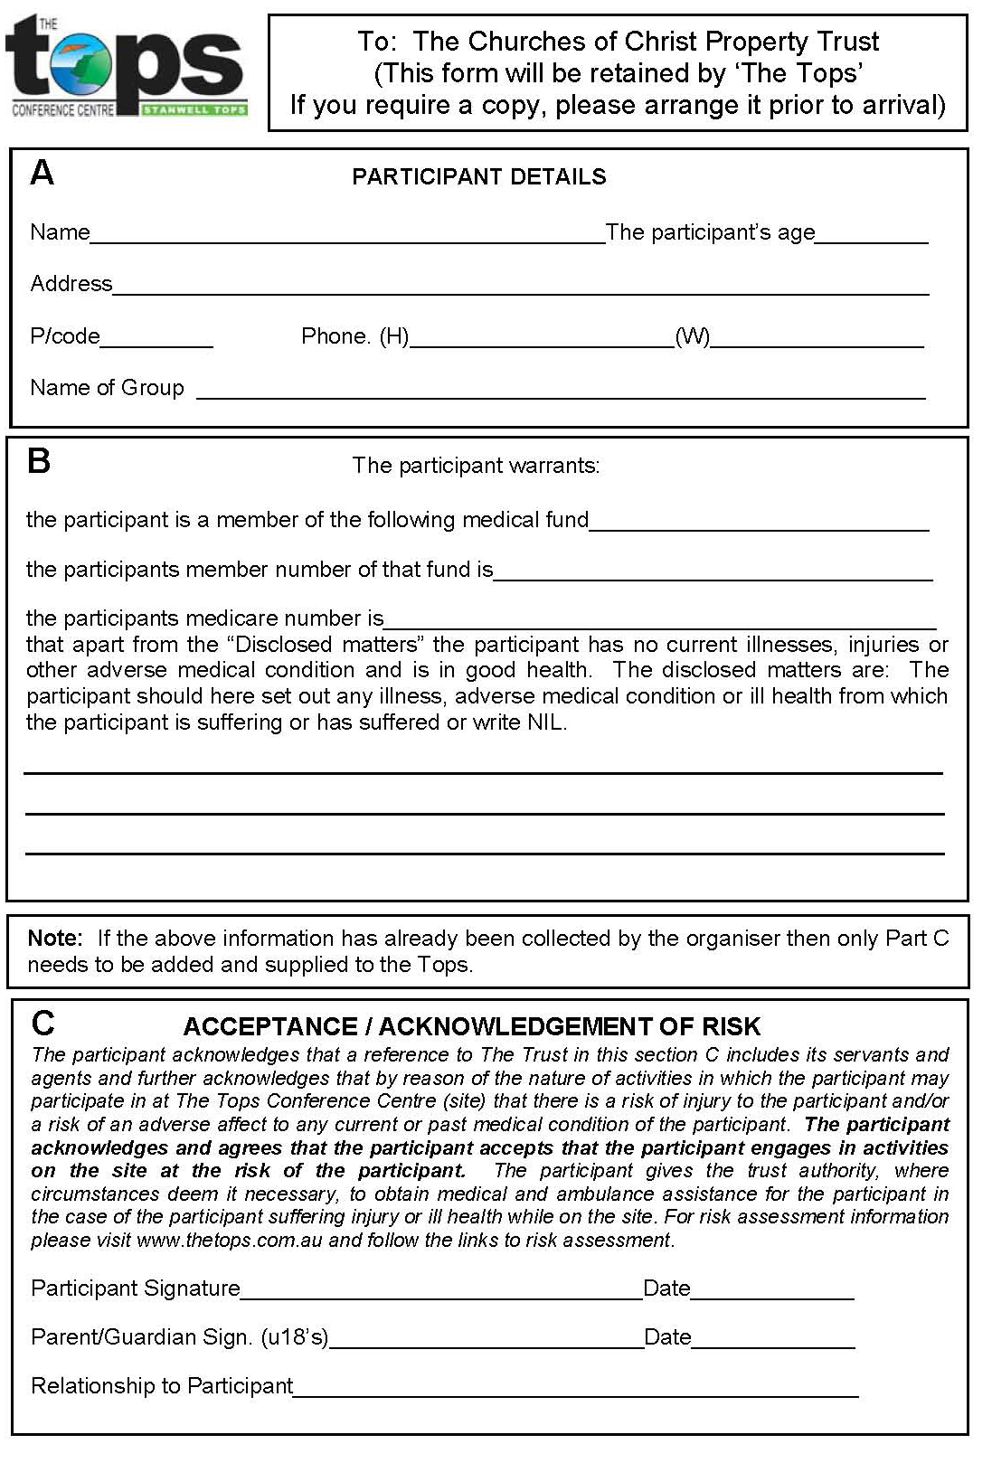

🞏 None